

**Public Health Commissioning Strategy:**

**2017/18 to 2020/21**

**Dr Victor Joseph,** Consultant in Public Health, Public Health Team, Adult Health and Well-being Directorate, DMBC on behalf of Public Health, DMBC

May 2017

**Table of Contents**

1. Introduction 1

1.1 Background 1

1.2 The Public Health Role of Local Authorities 1

1.3 The Public Health Grant 3

2. Developing the Commissioning Strategy: 5

2.1 Principle 1: Commissioning for Outcomes 6

2.2 Principle 2: Challenging existing and reviewing alternative service delivery models 7

2.3 Principle 3: Work in partnership 9

2.4 Principle 4 & 6: Understanding Needs and Promoting Resident Involvement 9

2.5 Principle 5: Social Value 9

2.6 Principle 7: Value for Money 10

2.7 Principle 8: Building Sustainability 14

2.8 Principle 9: Market Stimulation and Development 15

2.9 Principle 10: Corporate Social Responsibility 15

2.10 Principle 11: Equalities 15

3. Communication and Engagement 15

3.1 Who are our Customers? 15

4. Strategic Commissioning Objectives: 17

5. Approach to Strategic Planning 17

5.1 Public health grant 2017/18 to 2020/21 18

5.2 Proposed changes to start 2018/19 20

5.3 Overall Impact on the Public Health Grant Spend 33

5.4 Proposed changes to start 2019/20 or later 34

5.5 Key risks and issues 34

6. Conclusion 35

# Introduction

The purpose of this strategy is to describe how the commissioning activity of the Public Health team contributes to improving healthy life expectancy and improves the health of the poorest fastest in Doncaster.

## 1.1 Background

On 1st April 2013, the responsibility for local public health transferred to the Council. Each year, the Department of Health allocates an annual public health grant to improve and protect the health of health of the local populations. Doncaster Council (DMBC) uses this grant on all areas of public health expenditure including staff costs, DMBC support costs, an internal wider determinants fund and a range of commissioned services .The grant is included in the council’s Medium Term Financial Plan (MTFP) and is approved by council. This commissioning strategy outlines the commissioning approach taken by DMBC to maintain or improve outcomes whilst making the savings required by the national reductions in the Public Health grant over the next 4 years.

## 1.2 The Public Health Role of Local Authorities

The public health role of Local Authorities has expanded since the function transferred from the NHS to the local authority on 1 April 2013. The details of these initial responsibilities were set out in a number of documents, including in December 2011, the publication by the Department of Health of a series of factsheets collectively known as ‘Public Health in Local Government’ (gateway Reference 16747). The factsheets described: the Public Health leadership role for local government, detailed the new public health functions of local government, the role of the Director of Public Health, commissioning responsibilities, public health advice to NHS commissioners, professional appraisal and support and capacity building.[1]

The Council’s public health duty is to take such steps as it considers appropriate for improving the health of the people in its area. The factsheets suggest that an obvious way in which local authorities will fulfil this duty will be commissioning a range of services from a range of providers from different sectors, working with clinical commissioning groups and representatives of the NHS England to create as integrated a set of services as possible. However, local authorities can fulfil this duty in a wide range of ways, including the way they operate the planning system, policies on leisure, key partnerships with other agencies for example on children’s and young people’s services, and through developing a diverse provider market for public health improvement activities.  
  
The guidance factsheets suggest that local authorities will want to ensure the health needs of disadvantaged areas and vulnerable groups are addressed, as well as giving consideration to equality issues. The goal should be to improve the health of all people, but to improve the health of the poorest, fastest.

The Health and Social Care Act 2012 includes a power for the Secretary of State for Health to prescribe that local authorities take certain steps in the exercise of public health functions, including that certain services should be commissioned or provided. The purpose of this power is not to identify some services as more important than others. Rather the issue is that in some service areas (particularly health protection) greater uniformity of provision is required. In others, the Secretary of State for Health is currently under a legal duty and needs to ensure that that obligation is effectively delivered when a function is delegated to local government (the provision of contraception is an example). Finally, certain other steps are critical to the effective running of the public health system at a local level, for example, ensuring that the local authority provides public health advice to NHS commissioners.

The commissioning of other non-mandated services is discretionary, guided by the Public Health Outcomes Framework (PHOF), the local Joint Strategic Needs Assessment (JSNA) and the Health and Wellbeing Strategy.

The list of public health services that are mandatory (prescribed) and non-mandatory (non-prescribed) includes the following:[2]

***Prescribed functions (mandated services):***

1. Sexual health services – sexually transmitted infections (STI) testing and treatment
2. Sexual health services – Contraception
3. NHS Health Check programme
4. Local authority role in health protection
5. Public health advice to NHS Commissioners
6. National Child Measurement Programme
7. Prescribed Children’s 0-5 services

***Non-prescribed functions (non-mandated services):***

1. Sexual health services - Advice, prevention and promotion
2. Obesity – adults
3. Obesity - children
4. Physical activity – adults
5. Physical activity - children
6. Treatment for drug misuse in adults
7. Treatment for alcohol misuse in adults
8. Preventing and reducing harm from drug misuse in adults
9. Preventing and reducing harm from alcohol misuse in adults
10. Specialist drugs and alcohol misuse services for children and young people
11. Stop smoking services and interventions
12. Wider tobacco control
13. Children 5-19 public health programmes
14. Other Children’s 0-5 services non prescribed
15. Health at work
16. Public mental health
17. Miscellaneous, which includes:

* Nutrition initiatives
* Accidents Prevention
* General prevention
* Community safety, violence prevention & social exclusion
* Dental public health
* Fluoridation
* Infectious disease surveillance and control
* Environmental hazards protection
* Seasonal death reduction initiatives
* Birth defect preventions
* Other public health services

## 1.3 The Public Health Grant

The Public Health Grant is committed according to the Council’s budget book. In general terms, the investment is split across 3 areas, firstly non-controllable commissioned services, secondly controllable public health advice and corporate recharges and finally the wider determinants fund (i.e. realigned services) and contingency. The Local Authority Circular Gateway 18552 stipulates the conditions for the grant, and the monitoring arrangements.

The first area of investment is in the public health commissioned services provided by external bodies. This investment is directly linked to contracts and is non-controllable.

The second area of investment includes the staff salaries and controllable expenditure that is not linked to a contract but is used over the course of the year to improve health and reduce health inequalities.

The third area of investment includes both the wider determinants fund where the public health grant is used to resource activity (commissioned or provided) by another part of the Council that meets the Public Health Grant conditions and a small contingency for activity based contracts, which may over perform over the course of the financial year.

This Public Health Commissioning Strategy explicitly addresses the first and third areas of expenditure although the expenditure on staff costs is directly related to the commissioning activity proposed.

*Use of the Public Health Grant since 2013*

The table below shows how the Public Health grant has been allocated to date (Table 1). There was a significant increase in the grant in 15/16 and 16/17 as a result of the novation (the transfer of a new contract) of public health 0-5 services to the local authority. This increase masks the true cost of the services £6.725m in 2015 and 2016/17 but a grant increase of only £4.857m.

In Doncaster, the public health grant is also supplemented by additional income from outside bodies, other local and regional funding streams including the Better Care Fund, grants from the Police and Crime Commissioner and Public Health England, finally the public health team generates income through secondments or supplying public health expertise to external bodies.

In 2013 the wider determinants fund was created from the public health grant. This has been used to realign public health services previously delivered by the council that meet the criteria for public health grant.

**Table 1:** Public Health Grant 2013/14 to 2016/17

|  |  |  |  |  |
| --- | --- | --- | --- | --- |
|  | £ 000s | £ 000s | £ 000s | £ 000s |
| Year | 13/14 | 14/15 | 15/16 | 16/17 |
| Public Health Grant | 19,943 | 20,198 | 22,184 | 25,055 |
| Public Health other income | 326 | 326 | 468 | 605 |
| **Commissioned Services** |  |  |  |  |
| Sexual Health | 3,089 | 3,170 | 2,393 | 2,314 |
| NHS Health Check programme | 569 | 510 | 329 | 475 |
| Health protection | 129 | 73 | 182 | 60 |
| National Child Measurement Programme | 68 | 0 | 76 | 68 |
| Obesity | 667 | 840 | 711 | 257 |
| Physical Activity | 62 | 62 | 265 | 61 |
| Substance Misuse | 7,733 | 6,958 | 7,300 | 6,122 |
| Smoking and Tobacco | 1,407 | 1,300 | 1,369 | 949 |
| Children 5-19 public health programmes | 1,218 | 1,891 | 2,096 | 1,948 |
| Children 0-5 Health Visiting | 0 | 0 | 3,148 | 6,741 |
| Other public health services | 892 | 264 | 261 | 108 |
| **Sub-total Commissioned Services** | **15,836** | **15,068** | **18,130** | **19,103** |
|  |  |  |  |  |
| **Central and Support Services** |  |  |  |  |
| Public Health Advice (including Salary costs) | 1,912 | 1,647 | 1,567 | 1,117 |
| Parked Cut – use of ear marked reserves |  |  |  | -261 |
| Support services | 354 | 296 | 296 | 360 |
| **Sub-total Central and Support Services** | **2,266** | **1,943** | **1,863** | **1,216** |
|  |  |  |  |  |
| **Contingency used** | 516 | 100 | 0 | 0 |
|  |  |  |  |  |
| **Wider Determinants fund** | 1,325 | 3,676 | 4,019 | 5,341 |
|  |  |  |  |  |
| **Total Spend** | **19,943** | **20,787** | **23,986** | **25,660** |

*National Public Health Grant Reductions*

On 4th June 2015 the chancellor announced a £200m reduction in non-NHS Department of Health spending, which was translated into an in-year reduction in the Local Authority public health grants. The 2015/16 in year cut for Doncaster was confirmed at £1.464m or 6.2% (Letter from DOH 4th November 2015).

The Comprehensive Spending Review (CSR) on 25th November 2015 also announced a further reduction in the size of the public health grant. At a national level this is an average real terms saving of 3.9% each year to 2020/21. This is based on a revised baseline that makes the 2015/16 in-year cut a recurrent saving. This is a cash reduction of 9.6% over that period and at a national level this was phased at 2.2% in 2016/17, 2.5% in 17/18, 2.6% in the following 2 years and flat cash in 2020/21. The 2015/16 reduction amounted to £1.463m, a 16/17 reduction of £0.576m, 17/18 £0.618m and 18/19 an assumed reduction of £0.635m and predicted in 19/20 a further reduction of £0.618m

There have been no decisions about when a revised funding formula and a ‘pace of change’ adjustment might be brought in. In addition, the spending review has committed to retain the public health grant for 2016/17 and 2017/18, and from 2018/19 the public health grant will be replaced by a model based on retained business rates. Doncaster through the Sheffield City Region has agreed to pilot what this would mean in 2017/18. Finally no further information was provided about the health premium incentive scheme.

As a response to the 2015 in-year reduction a set of savings proposals were identified but a budget shortfall of £2.109m was predicted for 2016/17.This was subsequently addressed through a set of low risk and high risk proposals. The budget saving was made but there are now no tier 2 weight management services in the borough, still no public mental health services, and no specialised oral health promotion services. The growth funding and wider determinants funding was untouched by the in-year reduction but the staffing level of the public health function was reduced by 25%. Some of the savings proposals were not able to be implemented due to to a range of reasons including the practicalities of service changes e.g. substance misuse in Mexborough, sexual health ‘spokes’, others took longer than anticipated to release savings as services needed to ‘wind down’ and ensure those people using the services were effectively discharged and other savings although made had to be reinstated as the lack of funding and service created a major risk for the Borough e.g. infection control.

To date the 2016/17 position for the public health grant is a balanced position but this has required a higher use of reserves from the public health grant than anticipated (£261k). The use of reserves was appropriate as budget reductions are built into future reductions in contract values.

# Developing the Commissioning Strategy:

This strategy has been developed in keeping with the 11 principles outlined in the corporate commissioning and procurement strategy. The principles underpin the Doncaster strategic commissioning cycle (Figure 1).

The majority of the commissioning activity described in this document occurs at the level of the Doncaster population.

**Figure 1:** Doncaster strategic commissioning cycle.

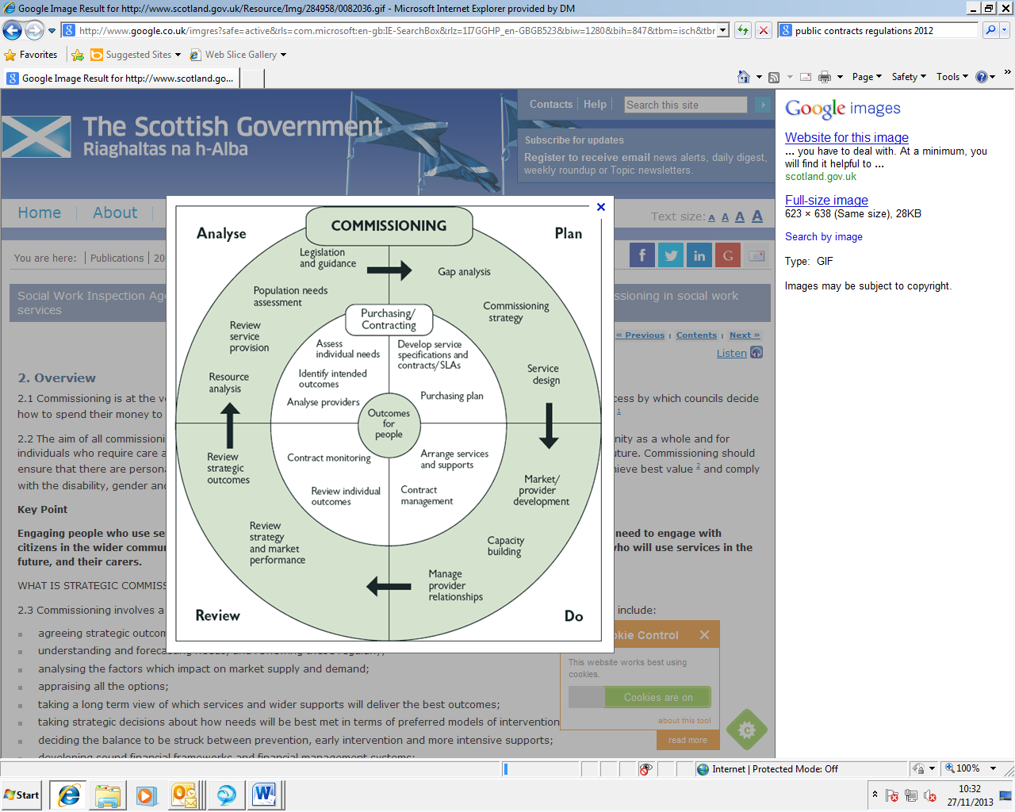

## 2.1 Principle 1: Commissioning for Outcomes

The Public Health team aims to commission for outcomes and quality as opposed to commissioning for inputs or volume and price. However, many services that were inherited from the NHS were commissioned for inputs (i.e. the number of staff), processes (delivery models), outputs (targets or indicators) or were commissioned to meet system level outcomes that were outside the gift of the individual service to deliver against.

Outcomes Based Commissioning requires an emphasis on ‘turning the curve’, identifying actions that will bring about change toward the desired results in terms of outcomes for populations and the performance of services. This relies on baselines, data, intelligence and insight, including the stories behind the baselines. It also involves forecasting the impact of specific interventions and makes effective use of simple population and performance information. Outcomes Based Accountability (OBA) is a useful tool for supporting outcomes-based commissioning.

All commissioning strategies associated with this framework will support the delivery of the high level population outcomes as set out in the Public Health Outcomes Framework.

## 2.2 Principle 2: Challenging existing and reviewing alternative service delivery models

Public health is a statutory duty for DMBC. It is sensible that the proposed programme of commissioned activity is reviewed to ensure the public health duty is delivered effectively, to review existing contractual arrangements, market test where appropriate and also to ensure the public health grant is used to the maximum effectiveness.

Over the time period of this strategy a number of contracts will expire and a range of new services will be required.

**Benchmarking:** Public Health functions and commissioned services can be benchmarked in a number of ways including performance against the public health outcomes framework, the quantum of the public health grant and effectiveness of the use of the grant.   
  
**Public Health Performance:** Doncaster performance on the Public health outcomes framework is worse than the national average for the headline indicators healthy life expectancy and difference in life expectancy (Figure 2). This is further shown in Health Profiles for Doncaster (Figure 3).

**Figure 2:** Life expectancy gap for men and women (in years) in Doncaster.



**Figure 3:** Health profile for Doncaster, September 2016



## 2.3 Principle 3: Work in partnership

The Public Health team will work in partnership with other agencies to improve health and reduce health inequalities. This may involve partnerships with co-commissioners both within Doncaster and in other geographies where there is evidence of benefit. In addition, in line with the Doncaster Place Plan further work will need to be done to integrate both commissioning and the provision of services.

## 2.4 Principle 4 & 6: Understanding Needs and Promoting Resident Involvement

Doncaster people are involved in the commissioning of public health services in a number of ways.

Firstly, the community, including patients and carers, are involved in contributing and producing the Joint Strategic Needs Assessment or other more targeted assessments. These assessments are used to identify strategic priorities including the priorities in the Health and Wellbeing Strategy. These contributions are also used by commissioners to set service user expectation of the service. The Public Health team will use the corporate community engagement toolkit.

Secondly as part of the public health contracts with providers each provider must provide an annual service user report to provide assurance that the service is measuring service user experience. Service users are also involved in validating whether services meet NICE quality standards where they exist for those services.

Thirdly, where changes to services or service models are proposed the public and patients and carers are involved in co-producing the new models with the explicit aim of making services more accessible and effective.

All these approaches require sharing of information along care pathways by other commissioners or involving the local Healthwatch.

## 2.5 Principle 5: Social Value

Many Public Health services are by nature preventative and geared to early intervention. The benefits to individuals far outweigh the costs of the prevention activity and may prevent future expenditure including both health and social care costs. Many public health services have wider economic benefits. For example, every £1 spent on smoking cessation saves around £10 in lifetime health care costs and health gains, according NICE estimates[3].

As part of this commissioning strategy economic, environmental and social benefits will be considered by appropriately using techniques such as Social Return on Investment. These techniques will be applied at the pre-procurement stage to ensure this commissioning approach takes account of the Social Value as defined by the Local Services (Social Value) Act 2013.

The Public Health team will also explore the potential of working with providers who pay a ‘living wage’.

## 2.6 Principle 7: Value for Money

Table 2 summarises the public health grant allocation for LAs in Yorkshire and the Humber. Across the region, the 2016/17 allocation per head of population varied from £32.8 per head to £97 per head reflecting the funding allocation formula, while Doncaster allocation was £80.2; and a total public health budget allocation was £25 million.

**Table 2:** Summary of Public Health allocation by local authorities in Yorkshire and the Humber in 2016/17

|  |  |  |
| --- | --- | --- |
| **Figures in**  **(£‘000s)** | **2016-17 Total allocation**  **(incl. 0-5)** | **2016-17 Total allocation per head (2015 MYE*)** |
| **England** | **3,387,460** | **61.8** |
| **Yorkshire and Humber** | **342,530 (10%)** | **62.0** |
| Barnsley | 17,888 | 72.9 |
| Bradford | 44,015 | 80.8 |
| Calderdale | 13,940 | 65.2 |
| Doncaster | 25,055 | 80.2 |
| East Riding of Yorkshire | 11,322 | 32.8 |
| Kingston upon Hull | 25,765 | 97.0 |
| Kirklees | 27,347 | 61.4 |
| Leeds | 46,630 | 58.8 |
| North East Lincolnshire | 11,603 | 70.9 |
| North Lincolnshire | 9,803 | 56.3 |
| North Yorkshire | 22,895 | 37.1 |
| Rotherham | 17,157 | 64.2 |
| Sheffield | 35,100 | 60.1 |
| Wakefield | 25,577 | 74.7 |
| York | 8,433 | 39.8 |

*ONS 2015 mid-year population estimates

**Financial performance: How do we measure value for money?**

Although the evidence on the cost-effectiveness of public health interventions is clear, measuring the impact of local investment in public health can be challenging. Public Health England with the Association of Directors of Public Health have published guidance on the public health grant and its use which includes information on how the impact of the grant may be seen locally (Public Health England, January 2017). This guidance has been used to identify possible indicators which could be used to monitor the impact of public health investment locally. All indicators shown are drawn from the Public Health Outcome Framework (PHOF). In November 2016, DMBC Corporate Strategy and Performance Unit (SPU) also carried out public health value for money benchmarking for a range of public health commissioned services. The value for money benchmarking exercise compared spends against outcomes in the following public health service areas:

* Obesity and physical activities
* Sexual health
* Smoking and tobacco control
* Substance misuse
* Child public health programmes
* Miscellaneous public health services (e.g. children 0-5 services).
* Additional measures (health protection, public health advice, and mental health support).

Examples of value for money benchmarking related to obesity (Figure 4a in adults; and Figure 4b obesity in children), and smoking and tobacco control service (Figure 5). The public health outcomes across a range of areas in Doncaster and other local authorities in Yorkshire and the Humber are shown in Figure 6 below.

**Figure 4a:** Value for Money benchmarking for obesity services (adults)

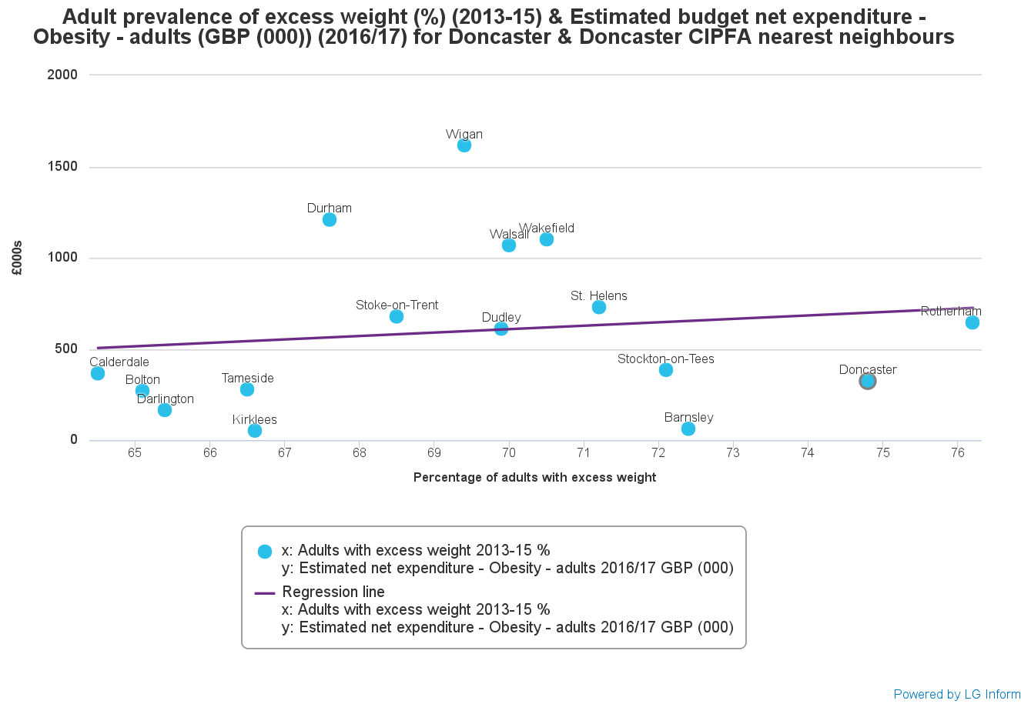

Doncaster

**Figure 4b:** Value for Money benchmarking for obesity services (children in year 6)

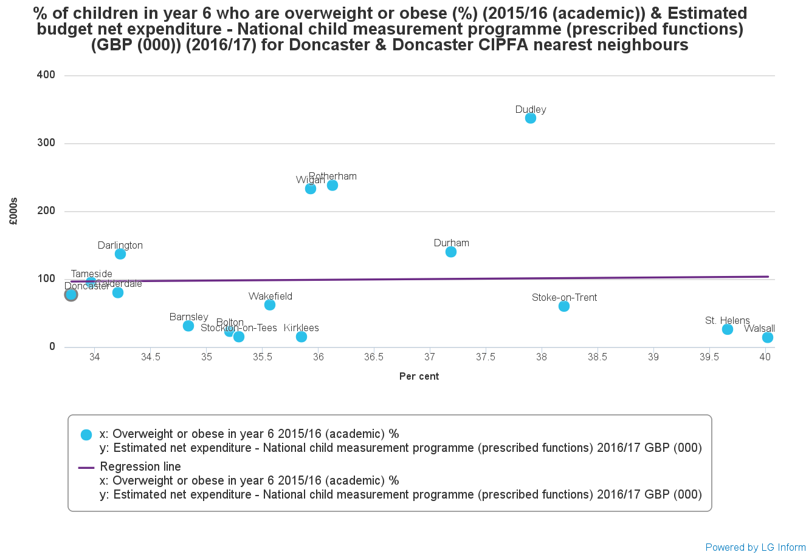

Doncaster

**Figure 5:** Value for money benchmarking for smoking service

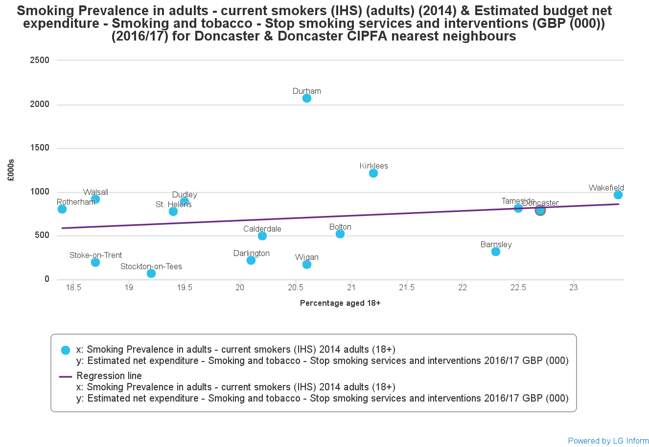

Doncaster

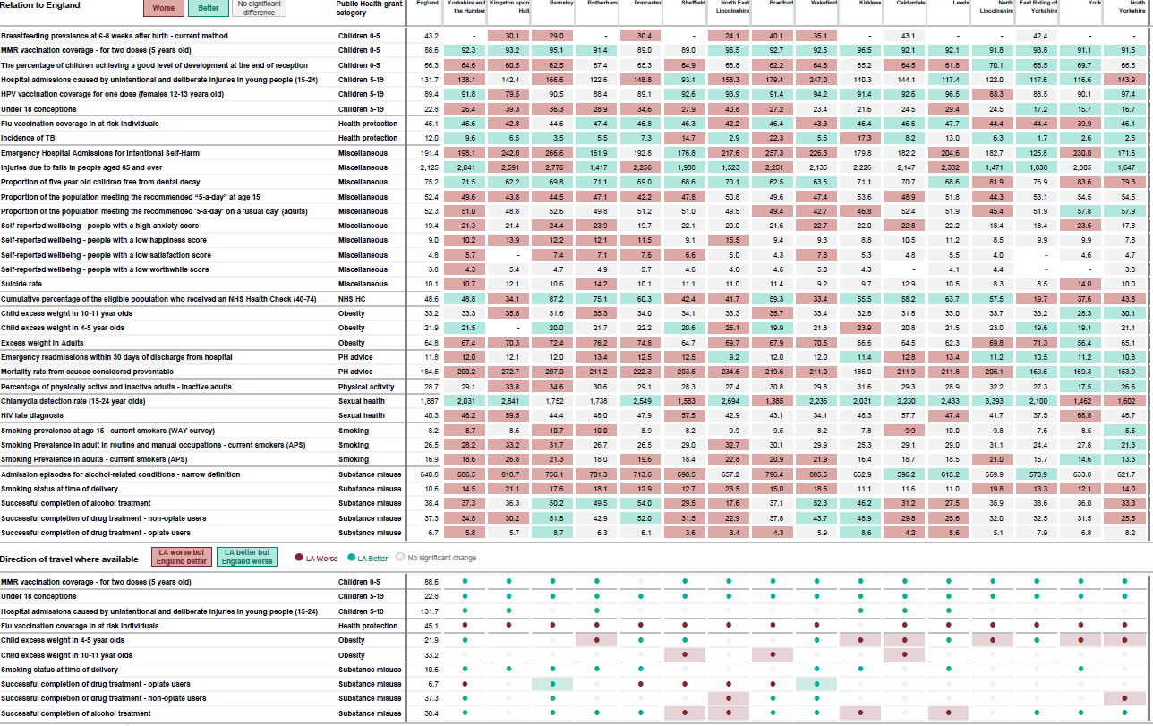

**Figure 6: I**ndicators used to monitor the impact of public health investment locally (PHE, September 2016)

**Cost-Effectiveness and Return on Investment:** Public health services are commissioned according to National Institute for Health and Care Excellence (NICE) guidance. Where these interventions are recommend they are deemed to be cost-effective and generate significant returns on investment for the local economy. For example, see the estimated costs of tobacco to the people of Doncaster, as shown in Figure 7.

**Figure 7:** Estimated cost of smoking in Doncaster

Source: ASH Ready Reckoner, 2016.

## 2.7 Principle 8: Building Sustainability

In line with DMBC policies, the Public Health team is looking to work with suppliers that are sustainable and contribute to reducing Doncaster’s carbon footprint.

Public health commissioned services are labour intensive. Any changes to these services including updated delivery models or reduced investment are likely to result in reduced income to our local providers and this is likely to be managed through reduced staffing and/or changed staffing levels within those local providers. Any tendering exercise may bring regional or national providers to Doncaster further affecting local providers and jobs. The directorate is keen to explore how other commissioning approaches including Alliance Commissioning could ensure providers are as sustainable as possible.

## 2.8 Principle 9: Market Stimulation and Development

Traditionally statutory services have provided the majority of public health services. In the past, the Public Health team held ‘soft marketing’ days to raise awareness of the possibility for other providers to deliver public health services. The team intends to hold further development days with providers. The information in this strategy will also inform a Market Position Statement.

Public Health fully supports the community innovation fund that is designed to develop providers including the third sector.

## 2.9 Principle 10: Corporate Social Responsibility

(Included in other principles)

## 2.10 Principle 11: Equalities

This public health commissioning strategy is one way that the Council can evidence how it discharges its Public Sector Equality Duty (PSED). Public health services have traditionally been targeted at the most disadvantaged groups and communities but in recent years these services may have become less focussed. For each area of public health commissioned activity the 2011 census data will be used to highlight the changes in demography and will be compared against the data captured by the providers in terms of those accessing the services.

The principle of tailoring services according to the needs of the population will be used in delivering public health services. This is also called proportionate universalism.

Where existing providers do not capture the relevant data this will be addressed in future years either as in-year contract variations or as part of a future procurement. Service user feedback and/or consultations will be used to fill major gaps in knowledge alongside reviews of the public health literature.

In general, the approach to empower individuals, families and communities to look after their own health (self-management) should contribute to increasing equality. This is supplemented by more robust equity profiling by providers.

One major challenge for the discharge of the PSED is the lack of detailed local knowledge of the knowledge, attitudes and beliefs of people from all protected groups for all health conditions. To address this, a proportionate approach will be adopted and supplemented with national research evidence. A ‘Due Regard’ Statement is separately completed.

# Communication and Engagement

## 3.1 Who are our Customers?

The Public Health team undertakes regular stakeholder analyses as part of service reviews, and Joint Strategic Needs Assessment. Stakeholders’ analyses will be an integral part of the proposed public health service.  
  
**External Customers**Doncaster residents and those in receipt of commissioned services  
Doncaster Communities (geographic and communities of interest)  
Current providers of public health commissioned services  
Health and Wellbeing Board and related partners  
Potential providers of public health commissioned services  
Health Watch Doncaster  
South Yorkshire Police and Crime Commissioner  
NHS Doncaster Clinical Commissioning Group  
Public Health England  
NHS England Area Team  
  
**Internal Customers**Mayor, Cabinet, relevant portfolio holders, elected members, Full Council and specific DMBC committees (e.g. Scrutiny)  
Public Health team  
DMBC Directorates  
Communication and Engagement plan  
  
**Residents**Residents have been consulted with on elements of the Joint Strategic Needs Assessment and the Health and Wellbeing Strategy. Service user feedback is embedded in contracted activity.  
  
**Staff**No direct consultation has happened with DMBC staff. There are currently no proposed changes to DMBC employed staff, but staff are consulted as part of the budget setting process.  
  
**Interdependent Programmes and Services**Existing providers have been communicated with about future proposals. Other future providers will be communicated with via YORTender and will be invited to ‘soft-marketing’ events.  
  
**Communication Channels and Frequency**This commissioning strategy will use routine communication channels to communicate with current and potential future providers, any staff affected by these changes and Members.

For each public health service area a separate communication plan will be developed in line with the procurement forward plan. These communication plans will include current and future providers, current and future service users, their families and carers, staff and members.

# Strategic Commissioning Objectives:

* To improve and protect the health and wellbeing of Doncaster people and improve the health of the poorest fastest.
* To improve the quality and effectiveness of commissioned public health services in line with available resources.
* To undertake the tender exercises for the proposed public health services.
* To align the commissioning of public health services with the commissioning of other services by DMBC or partners through the implementation of the Doncaster Place Plan.
* To maintain a wider determinants fund for use across the council’s public health duties.

* To develop the public health commissioning workforce.

# Approach to Strategic Planning

This commissioning strategy is an opportunity to improve the effectiveness and quality of the services currently commissioned by public health.

This strategy aims to deliver the public health commissioned services in order to deliver the Local Authority’s health improvement and health protection statutory duties. The Authority will take the opportunity to work with existing and new providers to remodel care pathways to maintain service quality whilst reducing costs.

This Public Health commissioning strategy links to the following Council’s strategic themes:

**Preventative Council:** The Public Health team commissions and supports a wide range of preventative services. Some of these address the causes of disease (smoking); all these services are being reviewed to ensure the local services deliver the cost/benefit ratios expected from the published literature. The Public Health team through the public health advice function provides access to the knowledge base and ‘what works’ evidence centres and has a track record of delivering nationally acclaimed programmes as well as embedding evaluation into routine work.

Increasingly prevention is considered to consist of both universal and targeted services.

The expenditure attributed to the public health commissioned activity is only part of the Council’s entire expenditure and leadership on public health. An integrated place based approach to public health investment may make the most effective use of the Council’s entire resource.

**Commissioning and Productive Council, Future Proofed services and Organisational Culture change:** The Public Health team is already a commissioning directorate. Seventy-six percent (76%) of the Public Health Grant is used to commission services from other parties. The directorate is already agreeing with other directorates joint work plans and is keen to maximise the effectiveness of an integrated approach to commissioning. In order to realise financial savings new models of delivery will be piloted and commissioned increasingly using technology where appropriate. The public health function has moved from the NHS to Local Government and is flexible and adaptable. Public Health is working with local partners as part of Doncaster Place Plan, with a shared approach to commissioning of services.

**Empowering & Community Council:** Any reduction in service activity will need to be supported by a changing approach to service users. In particular empowering people to take responsibility for their own, their families’ and their community’s health will be a key success criteria for this programme. In addition preventative services need to be seen as an extension to the community rather than a replacement of the community.

**Maximising our Assets:** The Public Health programme does not own physical assets but services that are commissioned by Public Health operate out of a number of premises. A more strategic approach to assets could reduce duplication and increase effectiveness of the commissioned services.

In addition to physical assets Doncaster and Doncaster people have a number of other assets that are identified in the Joint Strategic Needs Assessment and could be built upon to improve health. The service will be aimed at meeting the needs of Doncaster population, and individuals, families and communities of Doncaster to take control over their own health and wellbeing.

The public health team uses a range of tools and approaches to maximise the effectiveness of its commissioning activity e.g. multi-criteria decision analysis, Social Return On Investment etc.

**Procurement Implications:** This strategy describes the delivery of the proposed public health commissioned services together with the discharge of health improvement and health protection function. The transfer of public health responsibilities under the Health and Social Care Act 2012 had significant implications for the Council including the transfer of commissioning responsibilities for a range of public health services.

## 5.1 Public health grant 2017/18 to 2020/21

The national reductions in the size of the public health grant have been notified as 2.6% a year; a real terms saving of 3.9% a year. If no changes are made to the current commissioning portfolio there will be an overspend against the public health grant of £850,000 in 2018/19, £1,427,000 in 2019/20 and £2,045,000 by 2020/21.

This strategy proposes a pragmatic and phased approach to achieving a break even position on the public health grant. Whilst the national reductions in the public health grant have been mitigated to some extent by judicious commissioning by ensuring where any services tendered in the last 3 years have had built in reductions in contract values, there are still a number of significant commissioning decisions required. To support this approach there is a £500k public health contingency fund.

In 2017 four of the public health commissioned services require procurement as the existing contracts expire. These services are:

* 0-5 public health services including Health Visiting, Smoking in Pregnancy, Healthy Start vitamin distribution and targeted services for vulnerable families;
* Infection prevention and control services
* Doncaster Smoke-free Services
* Healthy Living for BME women in Doncaster.

If these services are procured within the expected financial envelopes then the overspend against the reduced public health grant can be brought down to £282,000 in 2018/19, £690,000 in 2019/20 and £1,138,000 by 2020/21.

In addition to the services being re-commissioned in 2017/18 a further key decision will be required by cabinet, in due course, to agree where future service changes may be required.

## 5.2 Proposed changes to start 2018/19

Four of the public health services are due for re-commissioning from 1 April 2018. They are part of Public Health Grant. These services are:

* 0-5 services including Health Visiting, Smoking in Pregnancy, Healthy Start vitamin distribution and targeted services for vulnerable families;
* Infection Prevention and Control services
* Doncaster Smoke-free Services
* Healthy Living for BME women in Doncaster.

**0-5 Services**

*The Description of Service Area:*

The aims and objectives of this service are that all children and their families receive the Healthy Child Programme (0-5), including universal access and early identification of additional and/or complex needs. This includes:

* Support families to give children the best start in life based on current evidence of 1001 Critical Days: The Importance of the *Conception to Age Two Period* as a foundation on which to build support in the early years and beyond;
* Provide expert advice and support to families to enable them to provide a secure environment to lay down the foundations for emotional resilience and good physical and mental health;
* Enable children to be ready to learn at 2, ready for school by 5 and to achieve the best possible educational outcomes.

Giving every child the best start in life is crucial to reducing health inequalities across the life course. The foundations for virtually every aspect of human development - physical, intellectual and emotional – are set in place during pregnancy and in early childhood.

All families with a child aged 0-5 years and all pregnant women currently resident in the local authority area must be offered the Healthy Child Programme via 5 mandated universal checks and assessments. The Healthy Child Programme promotes child development and aims to improve child health outcomes.

Smoking remains the leading cause of preventable death and disease in England. Smoking in pregnancy is a major contributor to higher infant mortality in the routine and manual socio-economic group. Doncaster has chosen to incorporate smoking cessation services for pregnant and post natal women into the 0-5 Healthy Child pathway. This integrated model sees specialist stop smoking advisors sitting alongside and working with Health Visiting teams.

*The Outcomes*

* Reduction in infant mortality
* reduction in smoking status at time of delivery
* Increase in breast feeding prevalence at 6-8 weeks after birth
* Increase in percentage of children achieving a good level development at the end of reception.

*The Proposed Actions*

The service will lead and co-ordinate local delivery of the Healthy Child Programme 0-5 requirements using the 4-5-6 model for Health Visiting, with a focus on the 6 High Impact Areas to support delivery (Figure 8).

**Figure 8:** Health Visiting 4-5-6 model

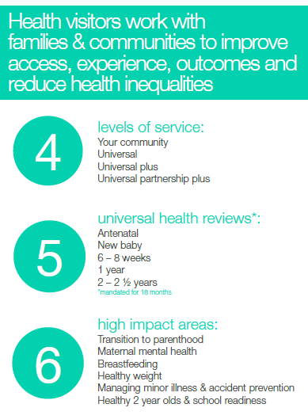

The universal Healthy Child Programme will be delivered through assessment of need by appropriately qualified staff; health promotion; engagement in health education programmes; involvement in key public health priority interventions and communities; and delivery of evidenced-based assessments and interventions.

The service approach should be to build on resilience, strengths and protective factors to improve autonomy and self-efficacy based on best evidence of child and adolescent development, recognising the context of family life and how to influence the family to support the outcomes for children.

*The Financial Impacts*

**Table 6:** 0-5 Public Health Service

|  |  |  |  |  |
| --- | --- | --- | --- | --- |
| **Public Health Services** | **2017/18** | **2018/19** | **2019/20** | **2020/21** |
| 0-5 Services | 6,771,000 | 6,264,675 | 6,108,562 | 5,956,349 |

**Infection Prevention and Control Service**

*The Description of Service Area:*

For the citizens of Doncaster, the Infection Prevention and Control Service means that the health of our residents in care homes are protected from infections by ensuring that there is appropriate service in place for preventing infections, and where there are any infections these are promptly controlled. The objectives of the service are:

* To provide expert proactive and reactive infection prevention and control (IPC) knowledge skill and experiential support to community health and social care providers.
* To provide training and support to develop a group of IPC champions across care homes. To support and enable healthcare workers to audit health and social care providers to ensure compliance with Care Quality Commission (CQC) requirements in relation to infection prevention and control and requirements in DMBC and CCG contracts and service specifications.
* To provide specialist infection prevention and control guidance to care homes and specialist training for DMBC contract monitoring officers.
* To support Public Health England (PHE) in providing the local level response to outbreaks of infectious disease under the direction of Public Health England Health Protection Teams.
* To conduct Post Infection Review (PIR) for specified cases and to ensure the learning from these processes is embedded.
* To provide advice on anti-microbial resistant organisms to community health and social care providers within the scope of this contract.
* To work with commissioners to provide the information required to scope the need for IPC services in the community.

*Outcomes*

The service will achieve the following key outcomes for the people of Doncaster:

* Reduced incidence of bloodstream infections from bacteria called Methicillin Resistance Staphylococcus Aureus (MRSA);
* Reduced incidence of Clostridium Difficile Infection (CDI);
* Reduced number of outbreaks of infectious diseases in health and social care settings in the community (care homes);
* Better training & education, audit, surveillance (e.g. CDI, MRSA) in the community including care homes.

*The Proposed Actions*

**Table 7:** Service activities for infection prevention and control

|  |  |
| --- | --- |
| **Infection Control Training** | Specialist IPC support to the local authority contract monitoring team and to the Care Quality Commission.  To provide training, to input or to deliver training to the level and frequency agreed. |
| **Health Care Acquired Infections including**  **MRSA and Clostridium difficile** | Post Infection Review / investigation for all reported community MRSA Bloodstream infections and CDI where no other healthcare provider is involved.  To facilitate post infection review processes for MRSA bacteraemia and take forward learning points.  To develop a work-plan and provide a regular report (initially monthly and quarterly thereafter) and a position statement in relation to the progress related to the annual work plan, including identifying gaps to the governance structure. |
| **Case Management** | To support Health and Social Care providers in the scope of this contract to manage a caseload of community MRSA, C. Diff and CPE cases including input to their families and carers to deliver targeted IPC advice to promote clearance and prevent secondary infection. |
| **Control of Notifiable Diseases** | Under the direction of the Health Protection Team at Public Health England (PHE) to:   * To support PHE where necessary to follow up cases of notifiable diseases. * Within the scope of the contract to provide advice to health and social care professionals. * Within the scope of this contract to support Environmental Health teams and contract monitoring teams at DMBC where required on the management of cases or outbreaks of foodborne pathogens. |
| **Infection Control Audits** | * To develop with the DMBC Contracts Monitoring team a protocol of managing the risk associated with IPC. * A tiered approach to Quality Assurance that is in place will be maintained. * The Contracts Monitoring Team will identify IPC concerns to the IPC lead delivering this contract. * Where serious concerns are identified within audits these should be communicated to the Consultant in Public Health and Director of Public Health as soon as practicable. |
| **Policies and Procedures** | The Service Provider will:   * Utilise Provider’s IPC policies and procedures to ensure consistent message. |
| **Achieving the**  **requirements of the Health and Social Care Act**  **2008 & 2010** | The Service Provider will:   * Work with colleagues based within DMBC to support them with compliance with the requirements of the Health and Social Care Act 2008 and 2010. * Work closely with the Care Quality Commission * Work with CCG colleagues |
| **Anti-microbial resistance** | * Work in collaboration with CCG Medicines Management Team in line with existing arrangements to support providers within the scope of this contract to ensure that they have access to relevant professional groups in order that people are prescribed antibiotics in accordance with local antibiotic formularies as part of antimicrobial stewardship. |
| **Links with environmental health** | The service provider will:   * Work in collaboration with local authority environmental health in collaboration with PHE teams to provider surge capacity during outbreaks. |

*The Financial Impacts*

**Table 8:** Infection Prevention and Control costs

|  |  |  |  |  |
| --- | --- | --- | --- | --- |
| **Public Health Services** | **2017/18** | **2018/19** | **2019/20** | **2020/21** |
| Infection Prevention and Control | 72,600 | 70,000 | 70,000 | 70,000 |

**Doncaster Smoke-free services**

*The Description of Service Area*

The average national (England) prevalence of smoking is 16.9%, whereas Doncaster prevalence of smoking is 19.6%. Smoking related mortality is also higher in Doncaster than the national average. An effective Doncaster smoke free service will reduce smoking prevalence and decrease smoking-related mortality.

The Provider will provide evidence based stop smoking support to people who are motivated to quit tailored to their level of addiction, quitting and medical history, personal factors and socio-economic classification. There is currently little evidence that smokeless tobacco and niche tobacco products are used significantly within Doncaster however the provider should assume that where clients use these products the appropriate level of support should be provided. The service should respond to the increasing use of electronic cigarettes by providing appropriate support to individuals who choose to change their behaviour by using these products.

Pathway of the Smoke-free service is shown below (Figure 9).

**Figure 9:** Pathway to Doncaster Smoke-free Service

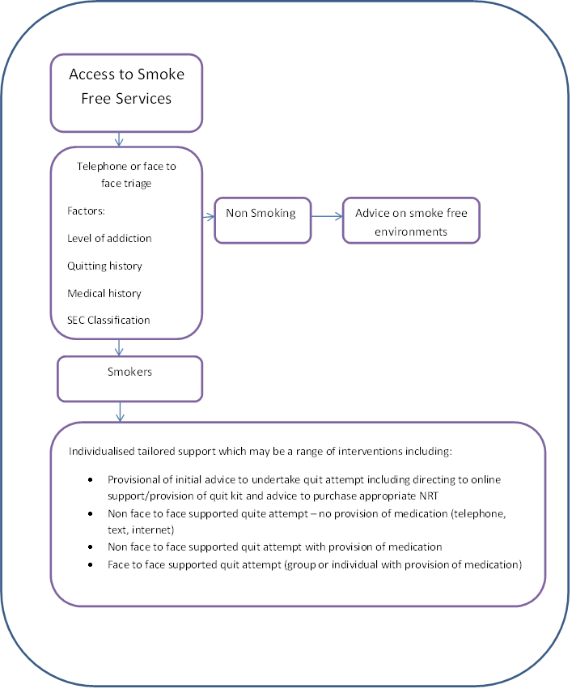

The Commissioners will allow the main provider to use sub-contractors to deliver stop smoking support, subject to their having achieved the appropriate levels of competence. The provider will remain responsible for clinical and financial governance and quality assurance of any sub-contractors.

*Outcomes*

* All clients to be offered individualised support commencing within 5 working days
* A quit rate of a minimum of 50% measured at 4-weeks for support with medication
* A quit rate of a minimum of 40% measured by self-report at 4 weeks for support without provision of medication
* Behaviour change at 6-months. 50% of those reported as quit at 4-weeks to remain abstinent.
* Client reported satisfaction rates to exceed 80%.
* Containing prescribing costs within a fixed prescribing budget
* Meeting the activity targets for quitting smoking, see below table.

**Table 9:** Activity Schedule: activity per annum with regard to seasonal variation above

|  |  |  |  |
| --- | --- | --- | --- |
|  | **2018/19** | **2019/20** | **2020/21** |
| Quits with medication | 1670 | 1670 | 1670 |
| Quits initiated no medication* | 4500 | 4500 | 4500 |

*Text, internet, quit kit, e-cigarette etc. self-validated by sampling

*The Proposed Actions*

**Access to services**

The service will accept referrals from individuals seeking advice and support or from an appropriate professional acting on their behalf.

Services should be accessible to clients including:

* Local rate telephone triage and support
* Opening hours to accommodate working clients
* Individualised support provided at locations across Doncaster that are convenient for the target client group. Providers are expected to organise their own clinic venues.
* Appropriate interpreter services
* Culturally sensitive services
* Access for people who have a physical or mental impairment that affects their ability to do normal daily activities.
* Online and other written materials should be in formats suitable for the client group.

**Telephone response times:** The provider should have systems in place to monitor call volumes and response times and adjust advertised opening hours and staffing as necessary. The provider should ensure that telephone calls are answered by a human operator within a standard time of 30 seconds.

**Waiting time for individual support:** clients should receive an offer to commence their treatment programme within 5 working days.

The provider should inform the commissioners if demand levels exceed agreed activity levels and response times. The provider should have procedures in place to prioritise clients during periods of peak demand and to manage activity across the year. See also section 3.6.

**Assessment**

All clients should be assessed and triaged into appropriate treatment programmes. The provider will take into account factors including:

* Level of addiction using a recognised assessment tool
* Socio-economic classification
* Previous quitting and medical history
* Key target groups agreed with the commissioners as outlined in this specification.

Smoke free and stop smoking assessments should be part of a broader, holistic public health assessment. Where appropriate referral to other public health services such as NHS health checks should be offered and documented.

**Advice**

Advice on smoke free homes and cars should be seen as a key component of every client interaction.

All advice given to clients will be based on the current clinical evidence. Caution should be exercised regarding advice on:

* Harm reduction, specifically cutting down the number of cigarettes smoked. There is currently no known safe level of smoking
* Cut down to quit. There has been no clear guidance on what is a safe or effective programme of cutting down to quit
* Electronic cigarettes. The provider should respond to the emerging evidence base whilst offering support to individuals who choose to use these products.

**Treatment programmes**

* All treatment programmes will be evidence based and delivered by suitably qualified stop smoking advisors. This does not preclude the development of new innovative programmes that have been agreed with the commissioners, and the premise of this specification is that an individualised tailored approach is adopted for every client.
* Harm reduction programmes are not included within the scope of this specification.
* Cut down to quit may be undertaken by clients however support will be restricted to text and general guidance (via websites for example) until evidence of what constitutes an effective programme becomes available. The commissioners will not fund Nicotine Replacement Therapy (NRT) for cut down to quit attempts.
* The provider will maintain appropriate and accurate records of client interactions to ensure the delivery of safe and effective care.

**Length of treatment**

The length of personalised support for all quit attempts will not exceed 7 weeks. The provider should offer guidance in a variety of formats to enable clients to maintain their quit status.

**Validation of quit attempts**

* All quit attempts and those supported by medication should be validated by the use of Carbon Monoxide (CO) monitoring.
* Quit attempts without the provision of medication will be validated by sampling 10% of clients for verbal confirmation of quit status.
* Additionally the provider will follow up a sample of 10% of clients at 6 months to assess sustained behaviour change.

**Provision of medication**

* The provider will retain responsibility for managing within a fixed prescribing budget and will invoice the commissioners quarterly based on actual spend.
* Where medication is to be provided the provider will assess, prescribe and arrange provision of the appropriate pharmacotherapy. The provider will undertake all necessary monitoring of clients receiving medication throughout their treatment course. Where clients are receiving prescription-only medication they should be encouraged to give consent to share this information with their GP. The provider will ensure that there are safe and effective medicines management systems when delivering services to clients. The provider must ensure that all staff provide and/or prescribe in accordance with relevant national and local guidance.
* The provider must ensure that staff who are non-medical prescribers follow national and professional standard policies and procedures for prescribing. In addition, non-medical prescribers will only prescribe within their role and area of competence. It is required that non-medical prescribers will undertake: clinical supervision, continuing professional development, and audit of their prescribing practice.
* NRT medication, in the form of a single product, will be issued on a weekly basis for the first four weeks and thereafter no more than 2 weeks supply at a time to a maximum total of 8 weeks supply.
* The provider should encourage the client to purchase a second NRT product to support their quit attempt where indicated.
* The commissioner will support the provision of dual therapy NRT in exceptional circumstances subject to the approval of the provider’s exceptional circumstance clinical procedure
* Varenicline will be issued as 2 weeks titration pack followed by 2 x 1 weekly and thereafter no more than 2 weeks at any one time to a maximum total of a 12 weeks course.
* Bupropion is not used in Doncaster in any significant quantities. Bupropion will be issued as 2 weeks titration pack followed by 2 x 1 weekly and thereafter no more than 2 weeks at any one time to a maximum total of an 8 weeks course.
* The commissioner will not fund the use of e-cigarettes in any circumstance or NRT for cut down to quit or harm reduction.

**Information Management & Technology**

The provider will have systems in place to record and produce reports on individual activity data and outcomes where applicable for all programmes and financial data including prescribing costs.

The provider is responsible for collating quit data from all associated services and sub-contractors and for the quarterly submissions to the Department for Health/NHS Information Centre and the commissioners.

All systems and communications should comply with all aspects of the Data Protection Act 1998 and the NHS Confidentiality Code of Practice and Caldicott principles.

The commissioners will retain ownership of all data and information collected from the service by the provider.  Any data, information or research pertaining to the service may not be transferred, disseminated or used by the provider without explicit permission from the Commissioner.

**Repeat attenders**

Activity data should differentiate between number of quit attempts and number of individual clients. As part of the assessment process the provider should ensure that clients are suitably motivated and supported to quit via the most appropriate modality for the individual at that time. As a guide, clients receiving medication should have a period of 6 months between repeat attempts.

**Service marketing and health promotion literature**

Marketing of the service and provision of accurate and up to date smoke free literature is the responsibility of the provider. The provider should produce an annual plan for approval by the commissioners.

All materials should carry the name of the service prominently and use the national smoke free logo and colours. Online and other written materials should be in formats suitable for the client group.

The provider may include their organisational name in small print only. All materials should be shared with the commissioner for approval.

The commissioners and their communications team should be notified in advance of any significant service activity such as key promotional events or other newsworthy activities.

**Equipment**

The provider is responsible for the provision of all equipment necessary for the delivery of the **service** and to use and maintain in accordance with the manufacturers’ instructions and current infection control guidance.

**Service Development**

The provider should have a programme of clinical audit agreed with the commissioners annually to support the developmental nature of this service.

*The Financial Impacts*

**Table 10:** Financial cost for Doncaster Stop Smoking Service

|  |  |  |  |  |  |
| --- | --- | --- | --- | --- | --- |
|  | Finance schedule (indicative breakdown based upon available budget), the final schedule will be based upon the tenderers bid. | | | | |
| Service Costs | 2017/18 | 2018/19 | 2019/20 | 2020/21 |
| Service costs (90%) | £447,342 | £413,790 | £363,105 | £354,024 |
| Quality premium (10%) | £41,379 | £40,345 | £39,336 |
| Medication Costs | £235,353 | £235,630 | £235,630 | £235,630 |
| Total | £682,695 | £649,420 | £639,080 | £628,990 |

**Healthy Living for BME Women in Doncaster**

*The Description of Service Area*

BME Women experience poor health inequalities and often excluded from services that seem alien and intimidating due to unfamiliarity; cultural and religious reasons; language barriers; and little knowledge of the service provision available.

The service will provide BME women across Doncaster with support around their health but is expected to concentrate this support in the most deprived areas where BME women are more vulnerable to poorer health outcomes. The service will work in, with, and for women in these communities to improve:

* general health outcomes
* access to services
* support for wider social and well-being needs.

A community centred approach such as this again links to NICE Guidance PH9; Community Engagement where it is suggested that although community engagement approaches are used to inform (or consult with) communities they may have a marginal impact on their health, it does acknowledge that these activities may have an impact on the appropriateness, accessibility and uptake of services. They may also have an impact on people's health literacy (their ability to understand and use information to improve and maintain their health (NICE guidelines (PH9) 2008).

The guidance also advocates that a robust system of evaluation be built into the cycle of delivery. Therefore a detailed data collection system with clear milestones will be required to record the progress of each client clearly. It is expected that evaluation will be a constant process which listens to and considers feedback from the client group as well as other partner organisations. This will ensure the Healthy Living service evolves continuously to meet the changing population and needs of BME women.

*Outcomes*

* Improve the health and reduce inequalities among BME women across Doncaster
* Improve the health literacy of BME women.
* Improve knowledge of Public Health messages
* Improve social inclusion of BME women
* Increase number of opportunities across Doncaster for BME women to actively participate in self-help activities.

*The Proposed Actions*

**Performance Standards**

* The provider will attend quarterly contract review meetings at dates and times agreed with the commissioner on award of the contract.
* The provider will submit copies of monitoring returns to DMBC on a quarterly basis prior to the contract review meetings. Deadlines will be agreed with the commissioner on award of the contract. Further monitoring reports may also be required on an ad-hoc basis during the contract period.
* Additional indicators may need to be monitored dependant on the performance management requirements of DMBC. The provider will be expected to amend its data collection as required. Additional performance indicators will be developed with the providers to ensure the continuous improvement of services and also to reflect changes in national guidance and standards.
* In conjunction with the commissioner the provider will be expected to design and produce reports that clearly demonstrate the progress of the service.
* Providers will be required to demonstrate their co-ordination of and involvement in regular inter-professional and inter-agency meetings. This will include health professionals, third sector and any other relevant organisation.
* Service user views on their experiences and satisfaction levels will need to be measured through an on-going, systematic process to test whether the service is engaging with service users in a way that supports them. The aim of this process is to highlight any changes to service provision that are required to meet the needs of the service users.
* The provider may be required to present updates on the progress and delivery of the service to DMBC representatives such as the Overview and Scrutiny Committee.
* The provider must be aware of and be compliant with national and local safeguarding principles and policies.

*The Financial Impacts*

**Table 11:** Financial cost of Healthy Living for BME Women in Doncaster

|  |  |  |  |  |
| --- | --- | --- | --- | --- |
| **Public Health Services** | **2017/18** | **2018/19** | **2019/20** | **2020/21** |
| Healthy Living for BME Women in Doncaster | 50,790 | 50790 | 50790 | 50790 |

**Other contracts ending in 2017/18 but not yet seeking re-commissioning**

These public health services have their contracts ending in 2017/18; some of them will not be re-commissioned whilst others will be re-commissioned either in 2019/20 or 2020/21:

* Tier 3 Weight Management MDT (option for 24 months extension)
* Alcohol Concern’s Blue Light Project (no extension)

## 5.3 Overall Impact on the Public Health Grant Spend

If the four services outlined above are recommissioned then the likely impact on the public health grant is shown below in table 7. The overspend in 18/19 can be met (one-off) from the public health contingency leaving a final contingency of £220k.

|  | 2017/18 | 2018/19 | 2019/20 | 2020/21 |
| --- | --- | --- | --- | --- |
| £000's | £000's | £000's | £000's |
| Public Health Grant | 24,437 | 23,802 | 23,184 | 22,566 |
| Public Health Other income | 528 | 528 | 528 | 528 |
| **Total PH income** | **24,965** | **24,330** | **23,712** | **23,094** |
| **Expenditure: Commissioned Services** |  |  |  |  |
| Sexual Health | 2,297 | 2,272 | 2,272 | 2,272 |
| NHS Health Check programme | 475 | 475 | 475 | 475 |
| Health protection | 80 | 80 | 80 | 80 |
| National Child Measurement Programme | 68 | 68 | 68 | 68 |
| Obesity | 170 | 170 | 170 | 170 |
| Physical Activity | 76 | 76 | 76 | 69 |
| Substance Misuse | 5,832 | 5,832 | 5,832 | 5,832 |
| Smoking and Tobacco | 948 | 894 | 878 | 862 |
| Children 5-19 public health programmes | 1,926 | 1,867 | 1,821 | 1,821 |
| Children 0-5 Health visiting | 6,526 | 6,037 | 5,886 | 5,739 |
| Other public health services misc H&WB | 106 | 106 | 106 | 106 |
| Sub-total Commissioned Services | **18,504** | **17,877** | **17,664** | **17,494** |
| **Expenditure: Central and Support Services** |  |  |  |  |
| Public Health Advice (including Salary costs) 6% vacancy factor built in for 14/15 onwards | 1,211 | 1,211 | 1,211 | 1,211 |
| ear marked reserve (parked cut) | -273 | 0 | 0 | 0 |
| Support services | 353 | 354 | 357 | 357 |
| Sub-total Central and Support Services | **1,291** | **1,565** | **1,568** | **1,568** |
| **Expenditure (wider determinants)** |  |  |  |  |
| Realignment | 4,907 | 4,907 | 4,907 | 4,907 |
| Growth | 263 | 263 | 263 | 263 |
| Sub-total wider determinants | **5,170** | **5,170** | **5,170** | **5,170** |
| **Total Expenditure (commissioned + central & support + Wider determinants)** | **24,965** | **24,612** | **24,402** | **24,232** |
| shortfall i.e. income against expenditure | 0 | 282 | 690 | 1,138 |

## 5.4 Proposed changes to start 2019/20 or later

Further work will be undertaken to review contracts that require re-commissioning in 2019/20 or where savings are required to be made. According to current Public Health contract register (Appendix 1), the following services may need to be re-commissioned:

**For 2019/20 start:**

* Integrated sexual health service (option for 24 months extension)
* Psychosexual service (option for 48 months extension)
* NHS Health Check (option for 24 months extension)
* Primary falls prevention and physical activity service (option for 12 months extension)
* Respect Yourself Doncaster Website (option for 12 months extension)
* Pupil Health Related Behaviour Questionnaire (no extension).

**For 2020/21 start:**

* Adults substance misuse (option for 12 months extension)
* Integrated young persons’ health & wellbeing services (option for 24 months extension)
* School nursing service (option for 24 months extension).

## 5.5 Key risks and issues

There are 3 key risks to the proposed option of reduced and remodelled public health services.

1. **Substantial change in size or status of ring-fenced grant:** This option assumes that the public health grant continues to be ring fenced and there are no additional reductions in the size of the grant. A reduction in the grant will require additional savings and if the ring fence is removed the Council may choose to use the entire grant differently.. Future funding of public health grant may change, in light of Government proposal that public health grant will have to be met from funds raised by local authorities as business rates. Therefore, the amount of public health budget will dependent on how much funds each local authority is able to collect as business rates. A reduction in the grant will require additional savings and if the ring fence is removed the Council may choose to use the entire grant differently.
2. **Worsening Health Outcomes and the Introduction of Business Rates:** There is proposal for public health grants to be funded through the introduction of business rates collected by the Council. Details of this are not yet available. This may impact on the public health grant that is needed to deliver future public health services. Health outcomes in Doncaster are improving but are significantly worse than the national average. Any proposal that links the size of the public health grant to meeting specific health outcomes must be considered high risk. The best way to manage this risk is to maintain a broad portfolio of health improvement activity to maximise the Council’s ability to meet any proposed targets.

1. **Insufficient volume in contracts:** Current public health services run with almost no waiting lists. As reductions in investment in any programme are almost entirely related to staff costs there is a possibility that waiting lists will be generated for public health commissioned services. A reduced and remodelled approach to public health services has the best chance of avoiding this. Demand management strategies will be optimised but with many of these preventative services reducing demand for these services will increase future care costs borne by other parts of the Council especially Adult social care. Across all service areas the use of web-based services will be explored in order to reduce unnecessary face to face contacts.

There are also a number of cross cutting issues that can impact on this strategy. These include

* The development of the Doncaster approach to joint or more integrated commissioning both within DMBC and across the Team Doncaster partnership.
* The development of the Doncaster approach to more integrated provision of services as described in the Doncaster Place Plan including work on ‘complex dependencies’.
* The challenges faced by providers to continue to delivery services given the budget reductions to date.
* The capability and capacity of the staff in the public health directorate to deliver this strategy.
* The availability of information and evidence to inform the strategy.

# Conclusion

This strategy sets out the key commissioning responsibilities, ways of working and challenges for the public health team.

This strategy will be governed through public health existing structures, including Finance & Contract Group, individual service contract meetings, and Public Health Governance Group.

An implementation plan, risk register and issues log will be developed to support the delivery of this strategy.

**Appendix 1:** Current Public Health Contract Register, 2017

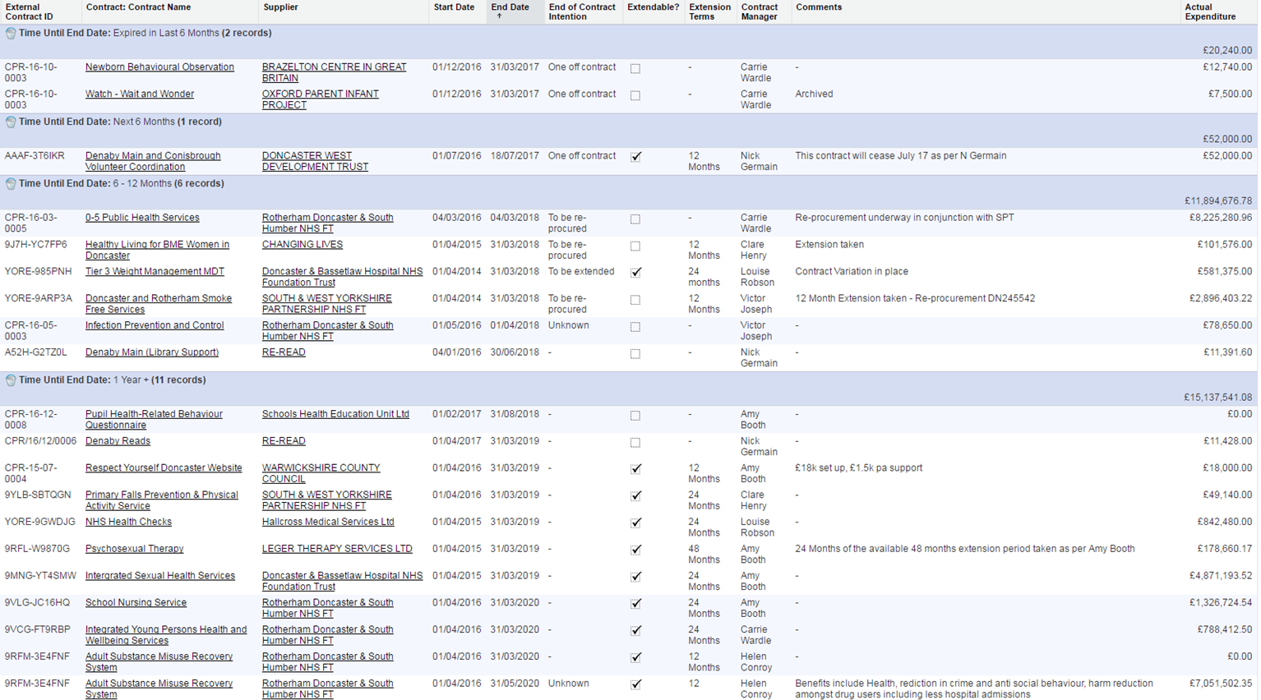

1. The new public health role of Local Authorities. Department of Health (2012). <https://www.gov.uk/government/uploads/system/uploads/attachment_data/file/127045/Public-health-role-of-local-authorities-factsheet.pdf.pdf>
2. <https://www.gov.uk/government/uploads/system/uploads/attachment_data/file/499614/PH_allocations_and_conditions_2016-17_A.pdf>
3. NICE. Tobacco Return on Investment Tool. <https://www.nice.org.uk/about/what-we-do/into-practice/return-on-investment-tools/tobacco-return-on-investment-tool>